# AIR-sEA INTERFACE UNDER TROPICAL CYCLONES

## Beaufort scale

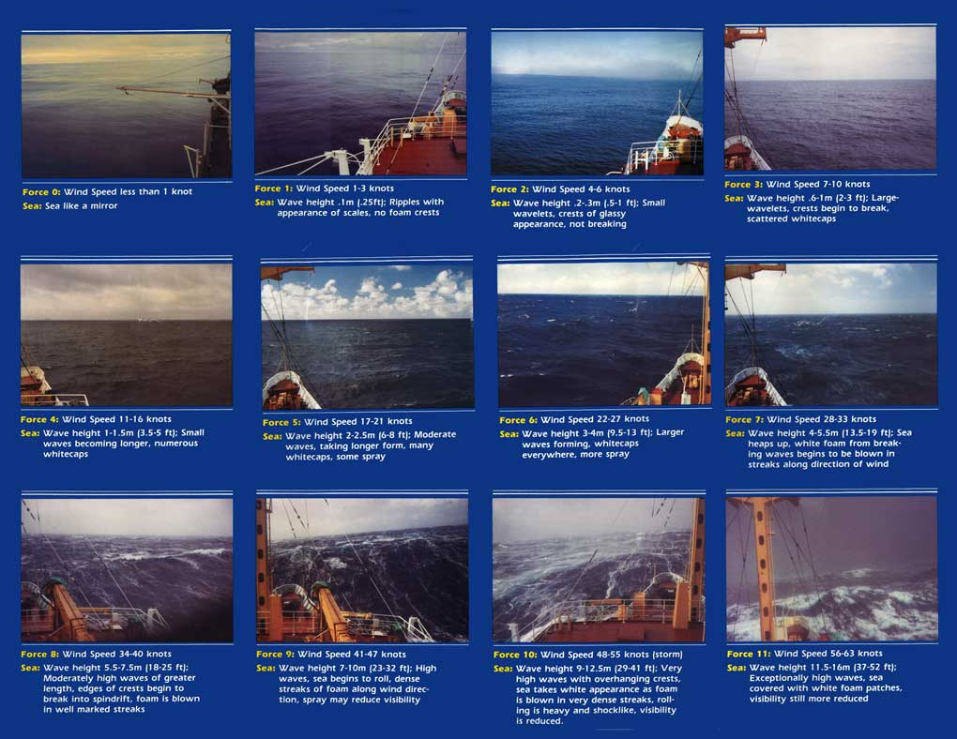

|  |  |  |  |  |  |
| --- | --- | --- | --- | --- | --- |
| **Beaufort number (force)** | **Wind Speed** | | **Wave height (feet)** | **WMO* description** | **Effects observed on the sea** |
| **knots** | **mph** |
|  |  |  |  |  |  |
| **0** | under 1 | under 1 | - | **Calm** | Sea is like a mirror |
| **1** | 1 - 3 | 1 - 3 | 0.25 | **Light air** | Ripples with appearance of scales; no foam crests |
| **2** | 4 - 6 | 4 - 7 | 0.5 - 1 | **Light breeze** | Small wavelets; crests of glassy appearance, not breaking |
| **3** | 7 - 10 | 8 - 12 | 2 - 3 | **Gentle breeze** | Large wavelets; crests begin to break; scattered whitecaps |
| **4** | 11-16 | 13-18 | 3½ - 5 | **Moderate breeze** | Small waves, becoming longer; numerous whitecaps |
| **5** | 17-21 | 19-24 | 6 - 8 | **Fresh breeze** | Moderate waves, taking longer form; many whitecaps; some spray |
| **6** | 22-27 | 25-31 | 9½-13 | **Strong breeze** | Larger waves forming; whitecaps everywhere; more spray |
| **7** | 28-33 | 32-38 | 13½-19 | **Near gale** | Sea heaps up; white foam from breaking waves begins to be blown in streaks |
| **8** | 34-40 | 39-46 | 18-25 | **Gale** | Moderately high waves of greater length; edges of crests begin to break into spindrift; foam is blown in well-marked streaks |
| **9** | 41-47 | 47-54 | 23-32 | **Strong gale** | High waves; sea begins to roll; dense streaks of foam; spray may begin to reduce visibility |
| **10** | 48-55 | 55-63 | 29-41 | **Storm** | Very high waves with overhanging crests; sea takes white appearance as foam is blown in very dense streaks; rolling is heavy and visibility is reduced |
| **11** | 56-63 | 64-72 | 37-52 | **Violent storm** | Exceptionally high waves; sea covered with white foam patches; visibility further reduced |
| **12** | 64 and over | 73 and over | 45 and over | **Hurricane** | Air filled with foam; sea completely white with driving spray; visibility greatly reduced |
| * World Meteorological Organization | | | | | |

## Ocean-atmosphere interface at very High Wind Speeds: Observations

Breaking waves are nowhere more evident than in tropical cyclones. Breaking waves create white caps, send droplets into the air, generate turbulence and exchange gases with the atmosphere.

They have been studied in the field [e.g., Ross and Cardone, 1974; Monahan and Ó Muircheartaigh, 1980; Holthuijsen and Herbers, 1986; Kraan et al., 1996; Sugihara et al., 2007; Callaghan et al., 2008a, 2008b; Kleiss and Melville, 2011] but always for wind speeds <23 m/s when breaking waves appear as white caps but related manifestations such as streaks and white-out are almost absent. Only the recent work by Holthuijsen et al. 2012 investigate this process using aerial reconnaissance films and GPS drop sondes in hurricanes under extreme conditions (0–500 m mean boundary layer wind speed UMBL up to 90 m/s). They concentrated on wind speeds UMBL > 25 m/s, when the white caps are joined by streaks, and eventually - at extreme wind speeds - merge into a white out (Figure 1).

A breaking wave creates a patch of active foam at its crest – the white cap. As the wave moves on, the leading edge of the white cap follows the breaking crest but the trailing edge remains stationary and is slowly replaced by submerged bubbles in wind-aligned streaks. At very high wind speeds the white cap is blown off the crest in a layer of spray droplets. Under such conditions, the ocean-atmosphere interface is a foam, spray, bubble emulsion layer, which acts

as a slip layer for the wind, rather than as a liquid surface [Powell et al., 2003; Emanuel, 2003].

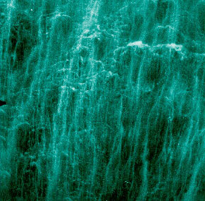

At very high wind speeds this layer covers the waves as a high-velocity white sheet, resulting in white out conditions.



Figure 1. Three sample frames of white caps and streaks under medium to extreme wind speed conditions. (a) Black-and-white (gray tone) frames from low-level air reconnaissance flights in hurricanes (fourth-order two-dimensional trends in gray tone removed; resulting gray tones normalized between 0 – darkest - and 255 - lightest). (b) White caps and streaks identified from Figure 1a as white and gray against blue background. Pictures were taken (left to right) from 159 m, 234 m and 453 m altitude. The estimated surface wind speed (10 m elevation) is indicated. Figure (1) from Holthuijsen et al. 2012.

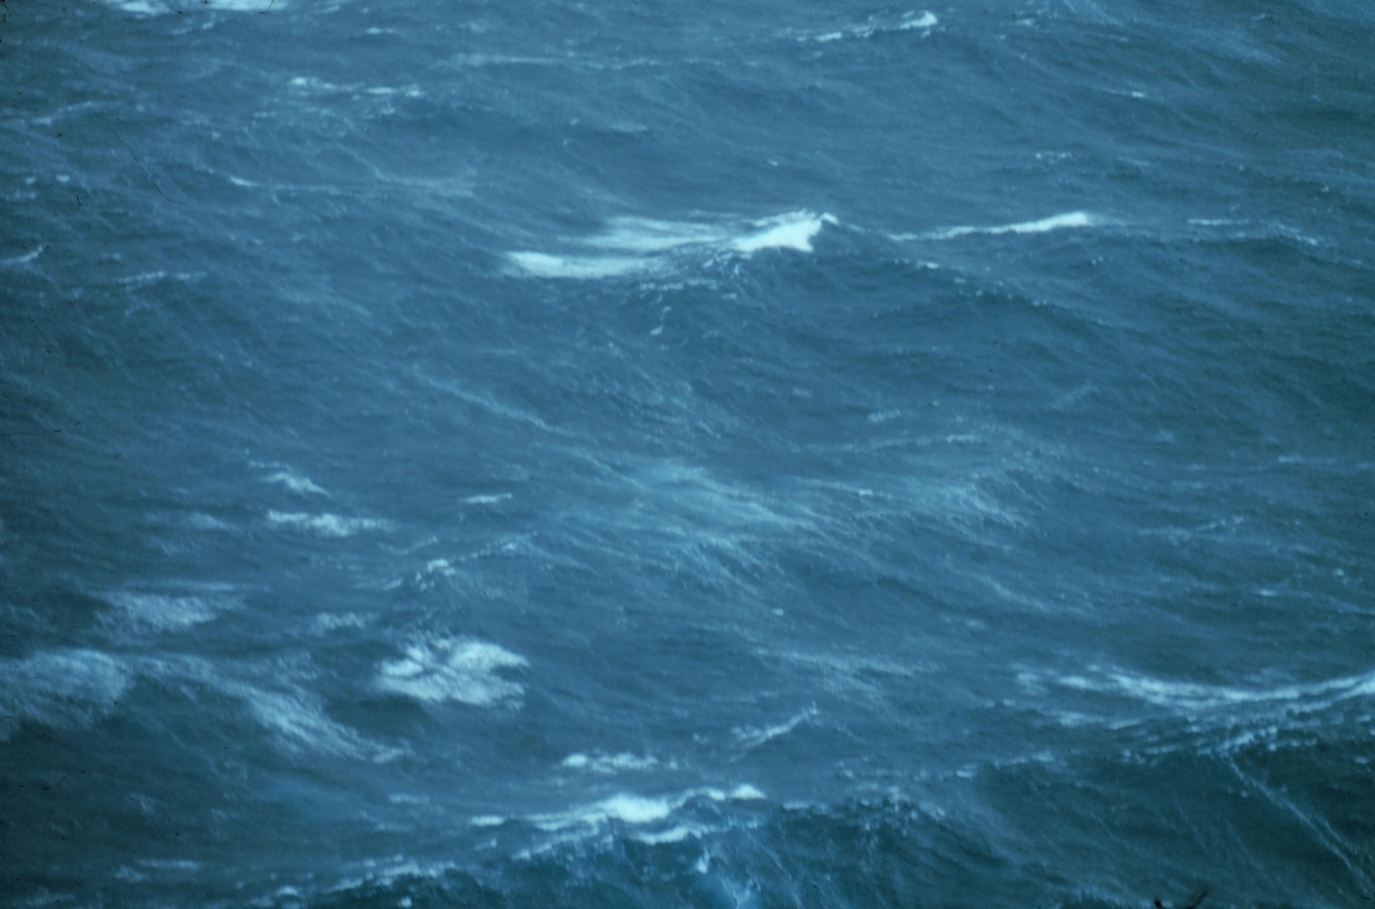

|  |
| --- |
| **Sea surface as observed from 500 feet in Hurricane Belle.** |
| **Image ID:** fly00164, Flying With NOAA Collection  **Photo Date:** 1976 August 8   **Category:** Aircraft/Heavy P-3/Hurricane/Sea Surface/ |

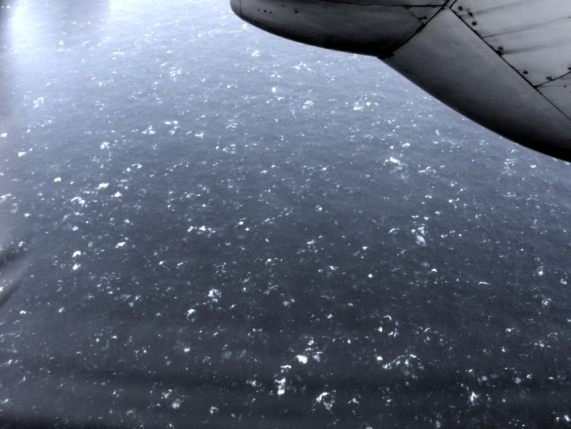

**into Dora July 22, 2011 sfc winds=50-55 knts**

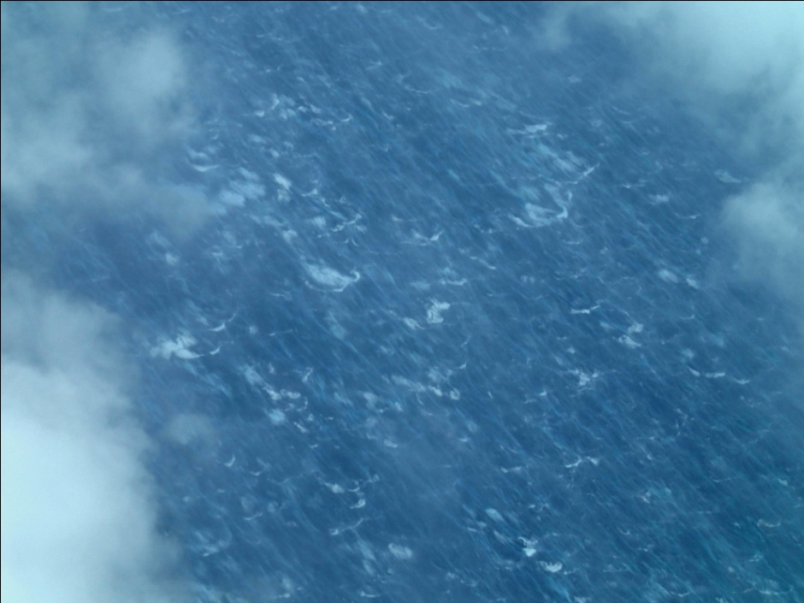

[Surface streaks in 65 kt winds  during Hurricane Edouard, 14 Sep 2014 by Paul Chang](http://www.aoml.noaa.gov/hrd/Storm_pages/edouard2014/wind_streaks_whitecaps_65_kt_Winds_Edouard_14SEP2014.jpg)

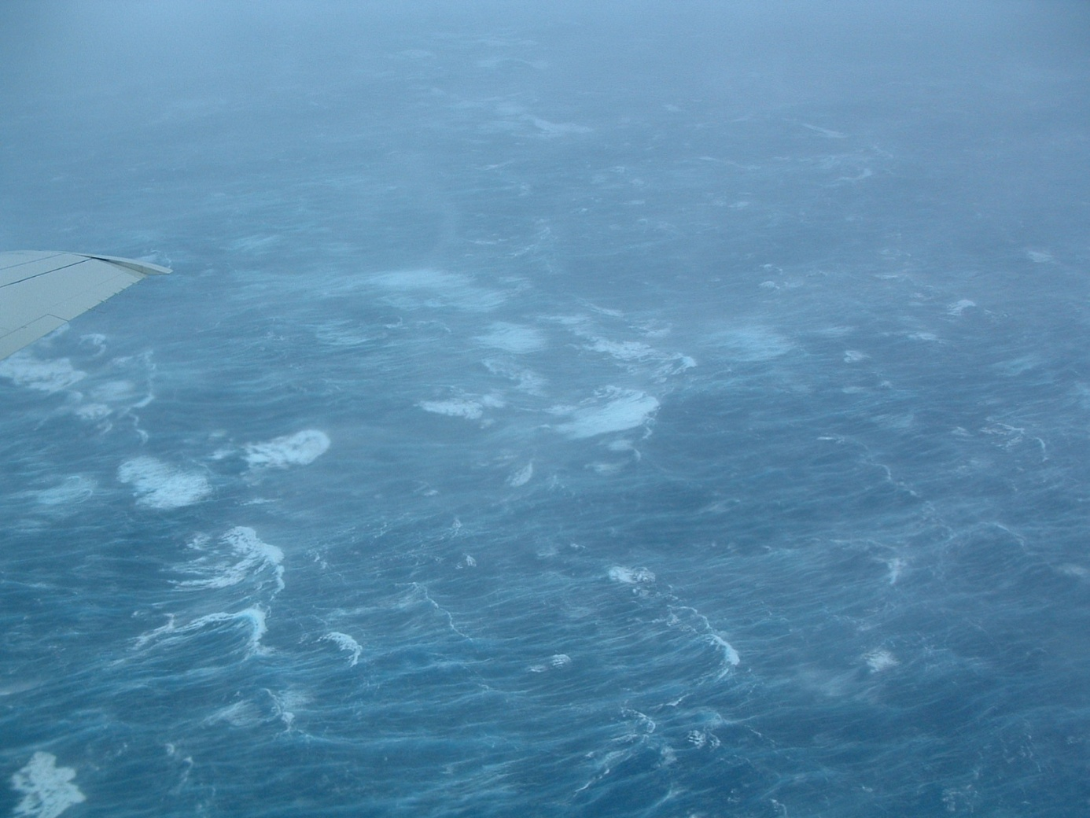

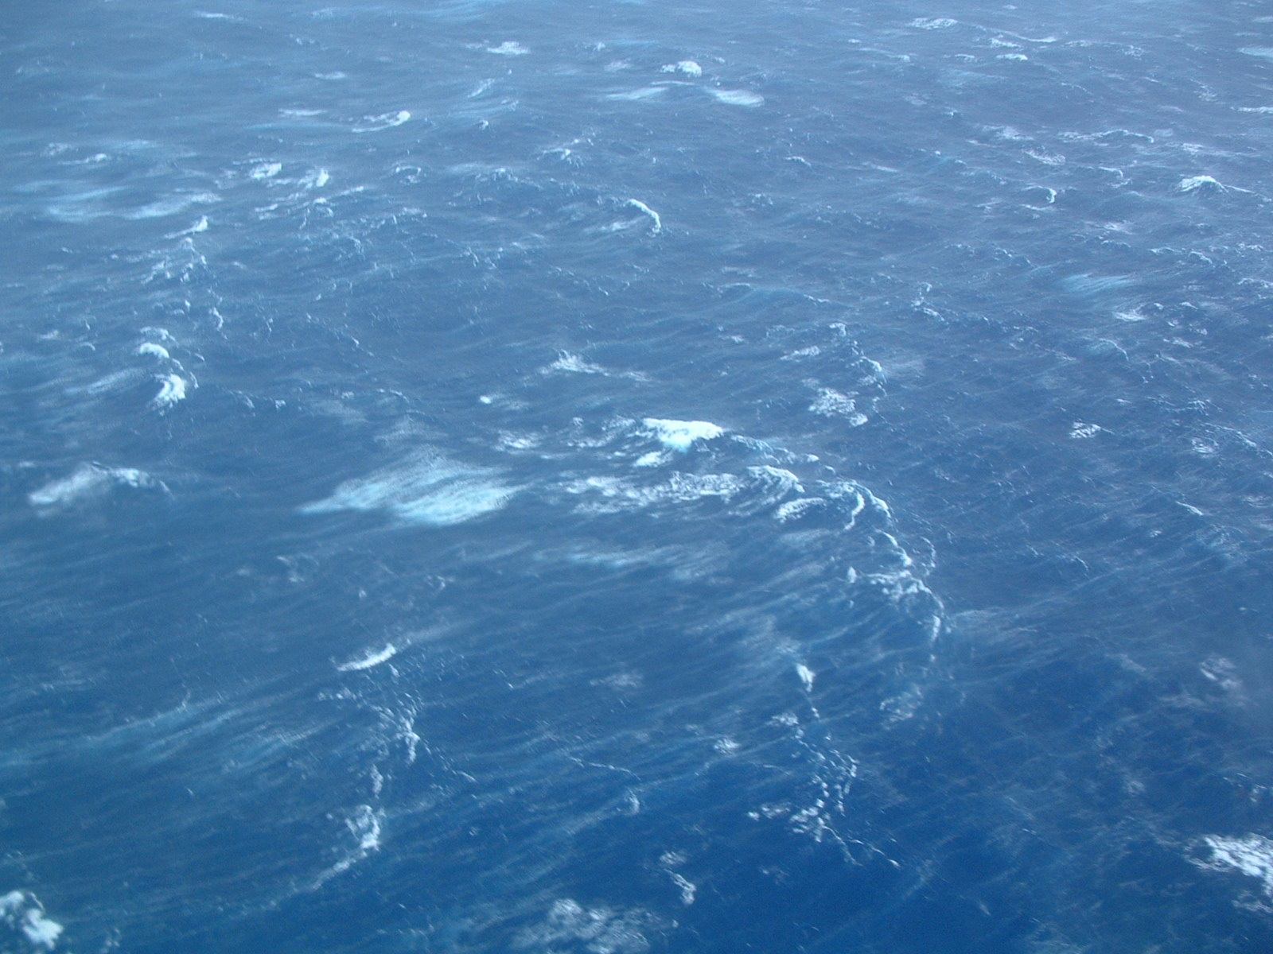

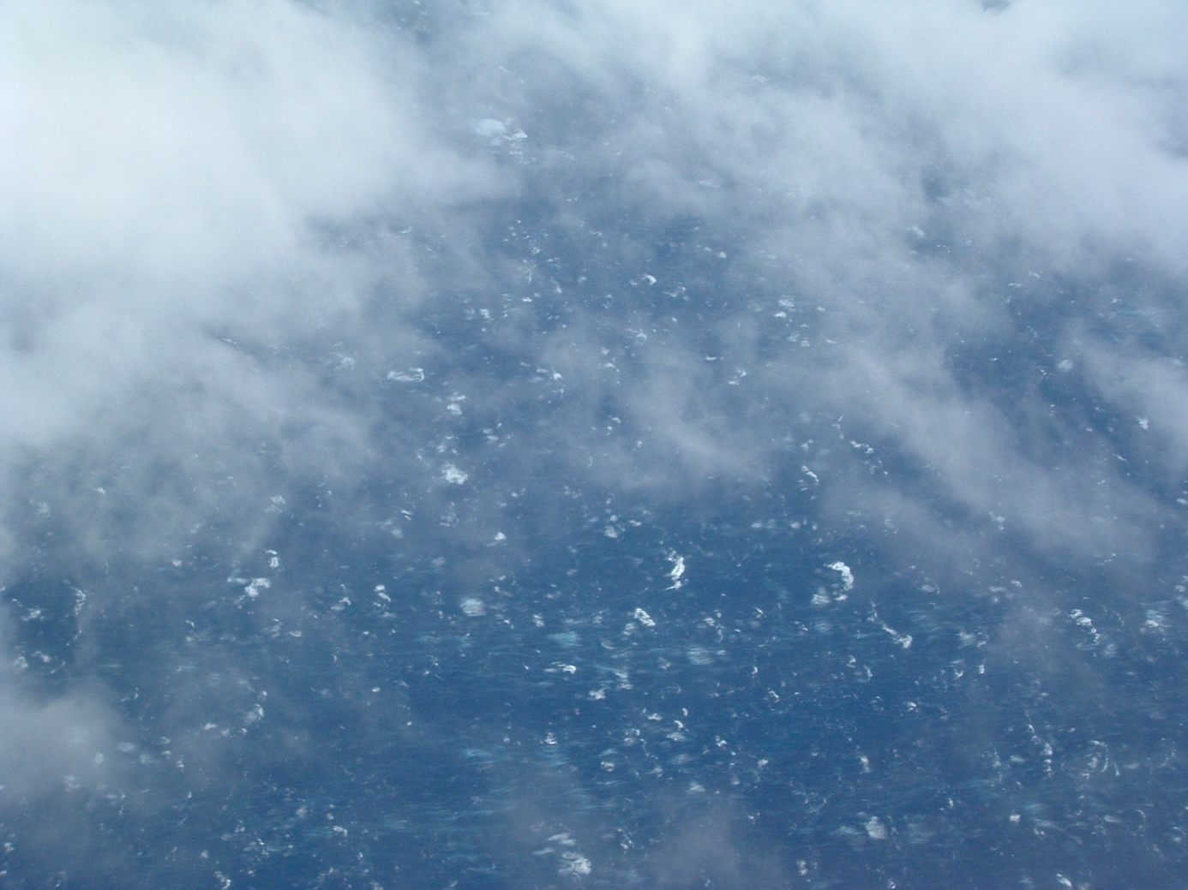

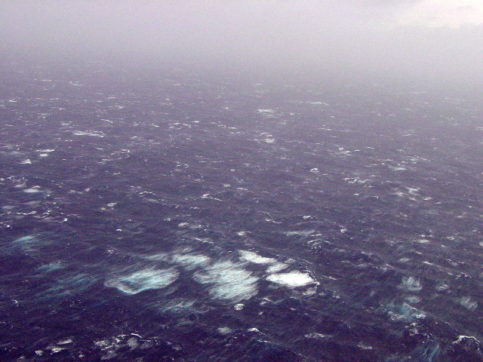

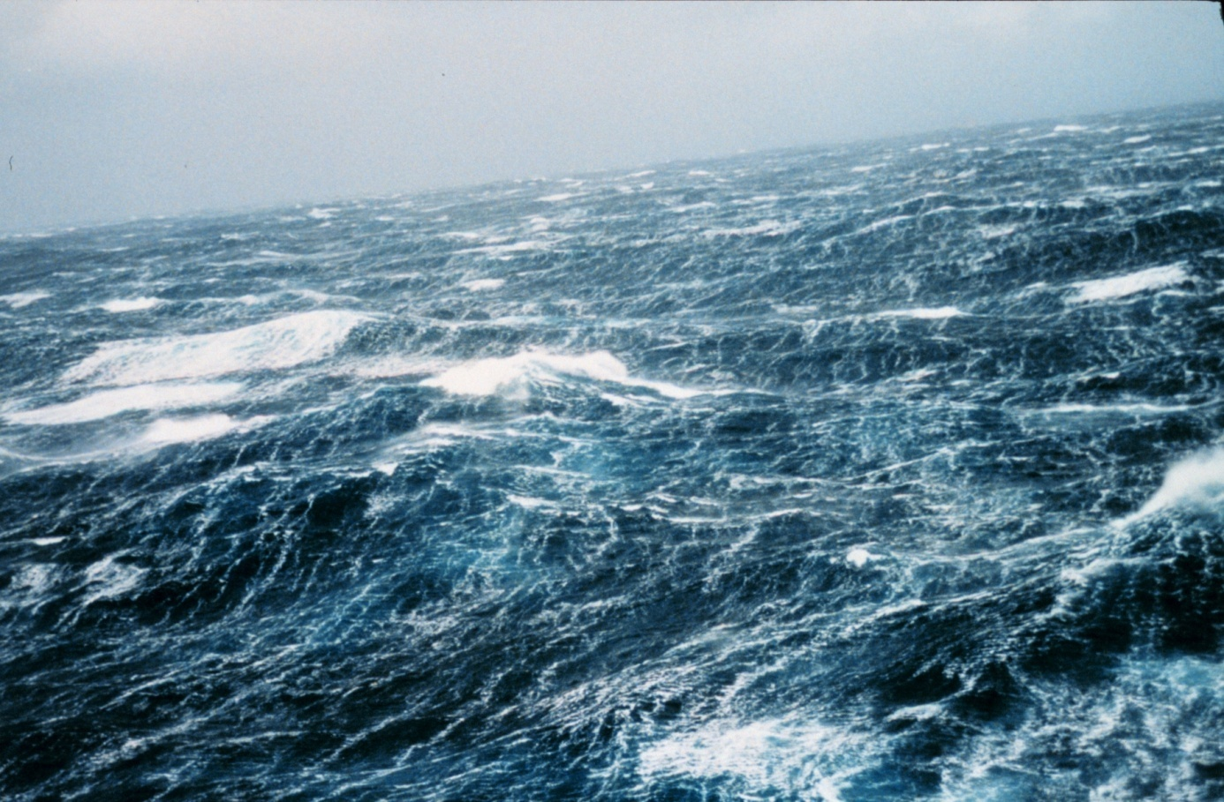

[North Pacific](http://en.wikipedia.org/wiki/North_Pacific) storm waves as seen from the [NOAA](http://en.wikipedia.org/wiki/NOAA) [M/V](http://en.wikipedia.org/wiki/Ship_prefix) *Noble Star*, Winter 1989.

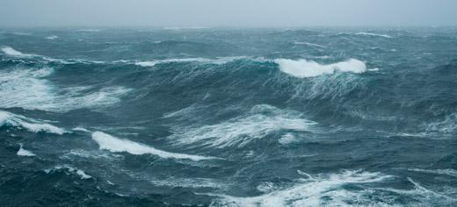

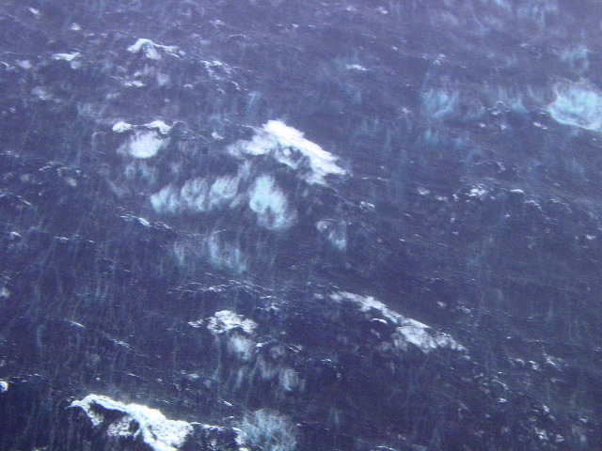

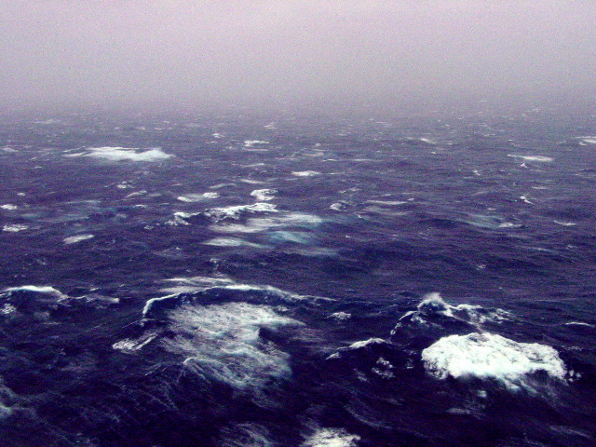

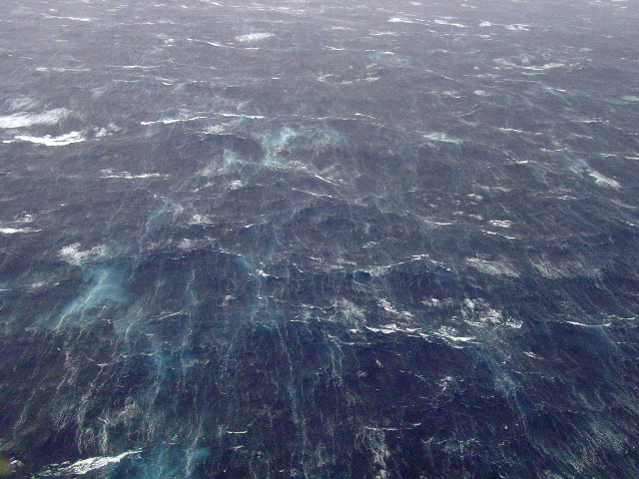

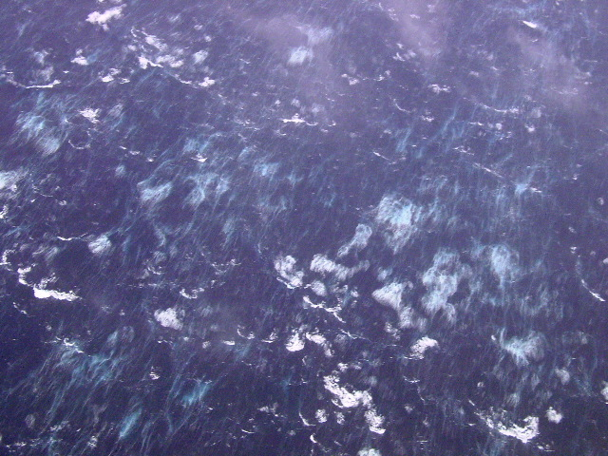

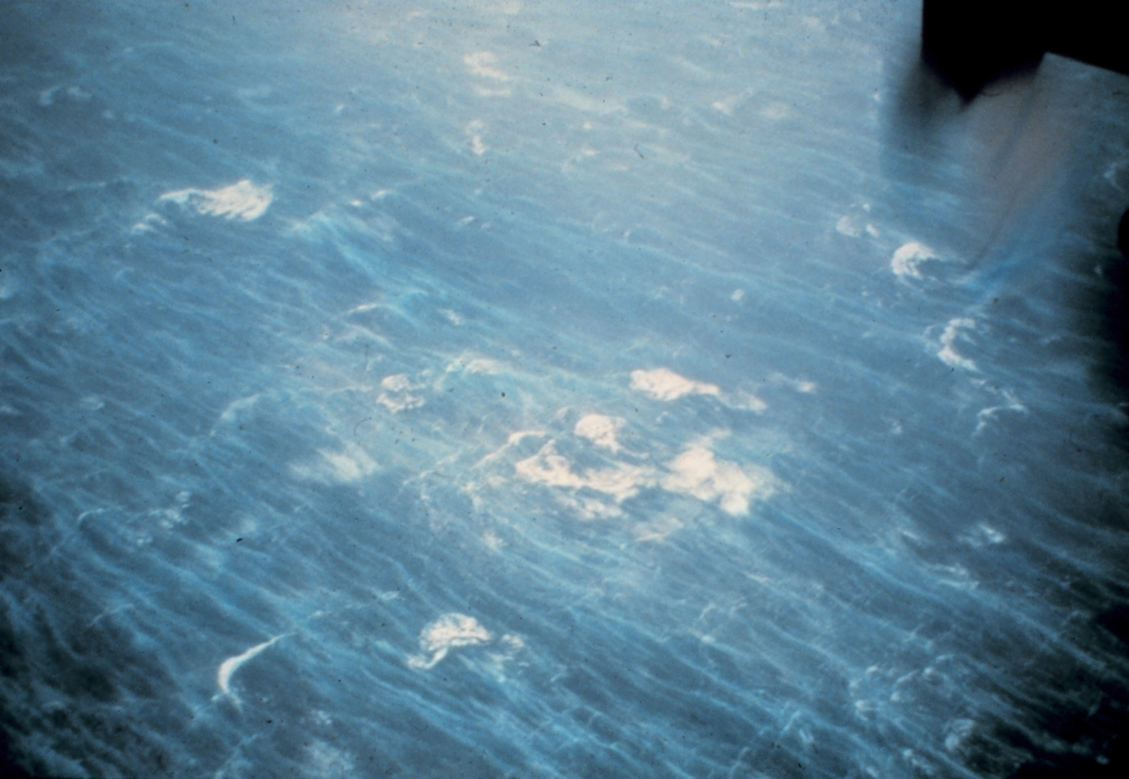

|  |
| --- |
| **Sea surface as seen from NOAA P-3 at 5000 feet during Hurricane Hugo. Seas were driven by over 100-knot winds and were 60-80 feet high.** |
| **Image ID:** fly00229, Flying With NOAA Collection    **Category:** Aircraft/Heavy P-3/ |

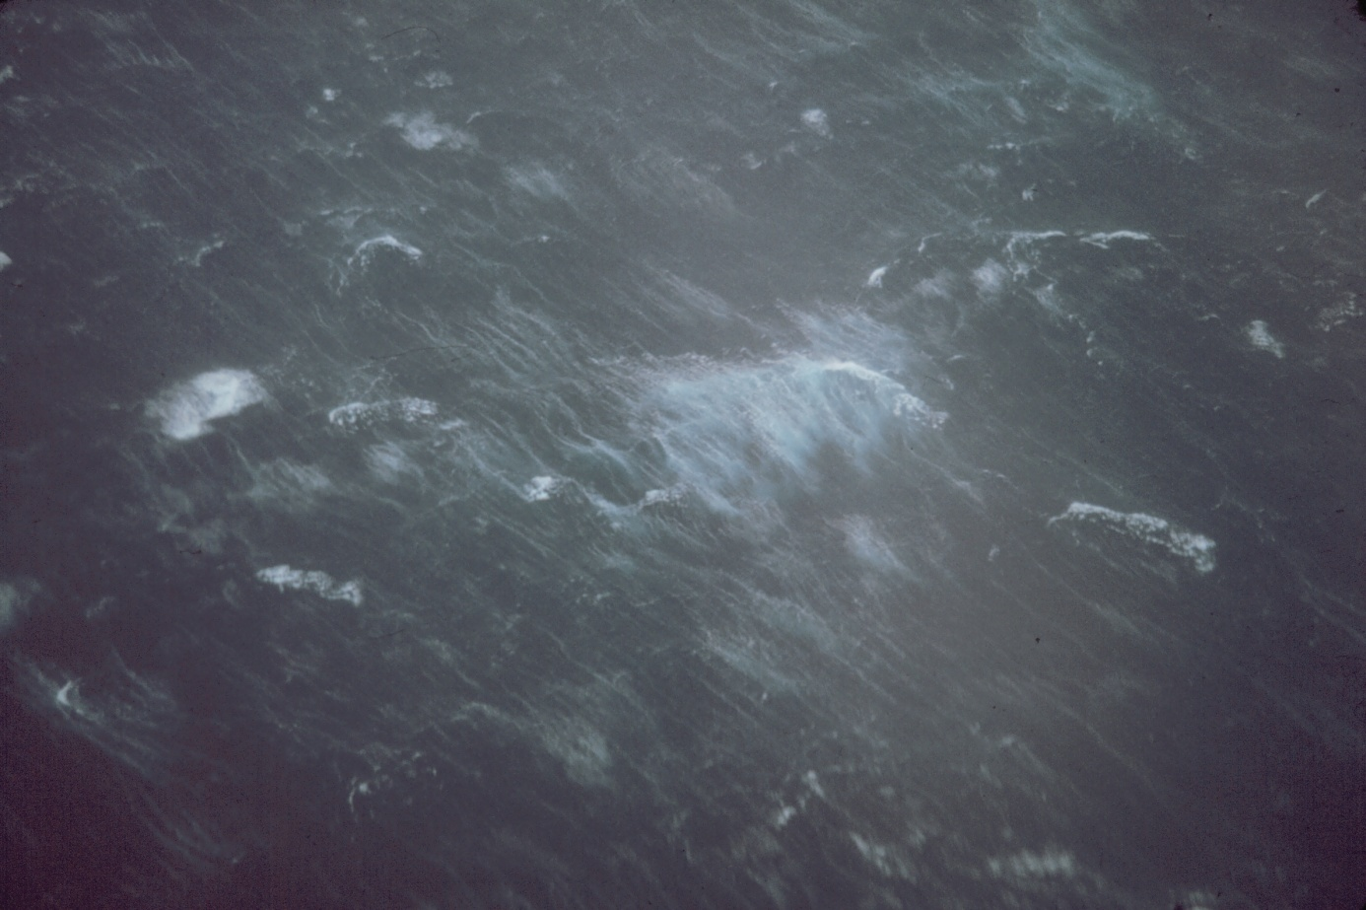

|  |
| --- |
| **Sea surface as observed from 1500 feet in Typhoon Kerry.** |
| **Image ID:** fly00171, Flying With NOAA Collection  **Photo Date:** 1979 February 21 |

# Modeling microwave foam emissivity

While sea foam can be defined broadly to include bubble plumes in seawater, foam layers at the surface, and, in some cases, sea spray droplets suspended closely above the surface (e.g., Newell & Zakharov, 1992), the foam skin depth at microwave frequencies narrows the scope to the surface expression of sea foam (AG11). We model, therefore, the emissivity of a foam layer floating on the surface and the dense bubbly mixture immediately below. Deeper bubble plumes and sea spray flying over foam-free or foam-covered areas also affect microwave signals (Barber & Wu, 1997; Plant, 2003; Tang, 1974). However, we do not consider their effects for now. Adopting the most widely used oceanographic terminology to distinguish active (newly-formed) and residual (decaying) sea foam, we state our interest in both of these stages of whitecaps [refer to Anguelova (2008, Section 2.1) for an extended foam definition]. Although modeling the emissivity of these two stages separately can be useful for air–sea interaction and remote sensing studies (AG11, Section 4.3; Anguelova & Hwang, 2012), we do not attempt such a separation in this study.

## Overview of sea foam properties

A layer of sea foam floating on the surface is an air–water mixture, with the seawater being an environment in which air bubbles are inclusions. To characterize sea foam and the processes within, the bubble dimensions (radius ***r*** and wall thickness ***w***) and concentration or size distribution ***N(r)*** are necessary. In addition to these microscopic characteristics, a set of macroscopic characteristics, including foam layer thickness ***t*** and foam void fraction ***fa*** (defined as the fraction of a unit volume of ocean occupied by air), describes the foam layer as a whole. These micro or macro characteristics establish a group of “medium” variables that represent the specific mechanical structure of sea foam.

A second group of “sensor” variables is needed to describe the detection of foam by sensors operating at various frequencies ***F*** and polarizations **P** (***P = H*** or ***V*** for horizontal or vertical polarization, respectively) at various incidence angles ***θ*** (Padmanabhan et al., 2006; Rose et al.,2002; Smith, 1988). The mechanical structure of a layer of sea foam on the ocean surface

comprises densely packed bubbles whose dimensions gradually change within the layer thickness (Anguelova, 2008). Large, thin-walled bubbles in the upper part of the foam layer provide low seawater content ***Q = 1 − fa*** and thus form dry foam. As the bubbles become smaller

and thicker-walled with depth, the air content ***fa*** decreases, making the foam wet. As a result of this vertical stratification of foam mechanical

structure and foam constituent contents, both micro and macroscopic foam characteristics acquire a wide range of values. For example, void

fraction could cover a full range of possible values, from approximately 100% at the air–foam interface to less than 1% at the foam–water interface (Anguelova, 2008, Section 2.2). The vertical stratification of the mechanical structure [e.g., ***w(z)***] and constituents [e.g., ***fa(z)***] of the sea foam leads to a vertical profile of the foam complex dielectric constant (relative permittivity, hereafter “relative” is omitted) ***εf(z)*** (Anguelova, 2008). This, in turn, dictates changes in all other dielectric properties of the sea foam (AG11; AG12).

Because of the dependence of seawater permittivity on seawater temperature ***Ts*** (Klein & Swift, 1977; Meissner & Wentz, 2002; Stogryn, 1997), variations of Ts within the foam mixture may result in variations of foam temperature in the foam layer depth Tf(z). Whether foam structure and constituents are constant (i.e., w = const, fa =const) or varying [i.e., w(z), fa(z)] with depth, the foam temperature profile Tf(z) would create the possibility for vertical inhomogeneity of foam dielectric properties εf(z).

Laboratory and field measurements have shown that sea foam has high, blackbody-like emissivity at microwave frequencies (Nordberg, Conaway, Ross, & Wilheit, 1971; Rose et al., 2002; Smith, 1988; Williams, 1971). According to Kirchoff's law of thermal radiation (Peake, 1959), this suggests that foam is a highly absorptive medium. The close packing of bubbles within a layer of floating foam suggests possible further attenuation due to volume scattering that occurs when ∂εf(z)/∂z ≠ 0. Since absorption, scattering, and transmission of EM radiation through a medium are determined by its dielectric properties, εf(z) varying with depth leads to variations in depth of the radiative

losses due to absorption and scattering. If volume scattering is present in a medium with a dielectric profile εf(z), multiple reflections within the medium should be treated as incoherent processes (Ulaby, Moore, & Fung, 1981, Section 4–14). That is, for each reflection among many scatterers only changes in the amplitude of the radiation field need to be accounted for because changes in the phase of the propagating radiation are randomly distributed.

Available photographs show that air–foam and foam–water boundaries are easily discernible, clearly distinguishing the foam layer as a separate entity from the bubble plume below (Peltzer & Griffin, 1987, Fig. 6b; Camps et al., 2005, Fig. 5). If the media on both sides of these boundaries are sufficiently dissimilar dielectrically, the boundaries will cause multiple reflections and transmissions of the radiation propagating through or emitted by the foam. Moreover, if these boundaries are rough on scales smaller than the wavelength of the propagating microwave radiation, these multiple reflections will deviate from specular reflection, giving rise to scattering from the rough surface.

Foam layer thicknesses encountered in the open ocean can range, depending on the wind speed, from 1 cm to more than 20 cm in active

whitecaps and from at least 0.1 cm to 1 cm in residual foam (AG11,Section 2.5). Since various meteorological and oceanographic conditions

affect the formation of new foam patches and their evolution from young to mature foam, there is a distribution of foam thicknesses

throughout the process (Reul & Chapron, 2003).

## Requirements for foam emissivity model

The overview of sea foam properties in Section 1.1 provides a guide to formulating general requirements that a model for the microwave

foam emissivity must meet. These are:

1) Model in terms of medium variables represented either with microscopic [r, w, and N(r)] or macroscopic (fa and t) quantities;

2) Model suitable for a range of sensor variables (F, P, and θ);

3) Vertical stratification of the foam structure expressed as vertical profiles of either microscopic [e.g., w(z)] or macroscopic [e.g., fa(z)]

characteristics;

4) Vertically inhomogeneous foam thermodynamic temperature Tf(z);

5) Non-uniform profile of foam dielectric properties in depth εf(z) due to either vertical variations of fa(z) [or w(z)] or Tf(z) or both.

6) Loss in foam due to absorption and incoherent volume scattering;

7) Surface scattering at irregular air–foamand foam–water boundaries;

8) Multiple reflections and transmissions at the boundaries of the foam layer;

9) A distribution of foam structural characteristics such as bubble dimensions (in microscopic terms) or foam layer thicknesses (in macroscopic terms) in open ocean due to geographic, meteorological and oceanographic variability.

Knowing what needs to be modeled, we review previous modeling efforts. Both empirical and physical models for microwave foam emissivity have been published.

## Empirical models of foam emissivity

Stogryn (1972) used reported radiometric measurements of foam to propose a model for the microwave emissivity of a 100% foam-covered

sea surface. The model involves the product of two functions — one introducing a dependence only on incidence angle θ (from 0 to 70°), and another presenting a dependence only on radiation frequency F (from 13.4 to 37 GHz).

Wilheit (1979) does not model foam emissivity specifically, but accounts for the effect that foam has on the surface reflectivity by evaluating

howmuch foam reduces it. The expression contains dependence on F and wind speed U.

Wentz and Meissner (2000) and Bettenhausen et al. (2006) follow an approach similar to Wilheit and model the modification of the surface

reflectivity caused by foam. This is done either by multiplying the surface reflectivity by or adding to it an empirical factor (determined from collocated satellite and buoy observations), which is a function of U and sea surface temperature (SST).

A common aspect of empirical models of the foam emissivity, or its effect on sea surface reflectivity, is that they do not involve the physical

characteristics of foam as a medium, but instead only take into account dependence on sensor parameters, θ and F, or environmental variables, such as U and SST.

## Physical models of foam emissivity

Physics-based models of microwave foam emissivity extend classical electromagnetic and microwave remote sensing theories of emissivity

and volume scattering of a medium with both uniform and non uniform profiles of physical properties (Brekhovskikh, 1980; Landau & Lifshitz, 1960; Sharkov, 2003, Chapter 7; Tsang, Kong, & Shin, 1985; Ulaby et al., 1981). Applied specifically to foam (in their entirety or just elements of them), these theories have a variety of ways to take into account the physical properties of foam.

The first physical model of foam emissivity ef was that proposed by Droppleman (1970). The model uses the effective dielectric constant of porous material [Anguelova (2008) established that this is in fact the well-known Maxwell–Garnett mixing rule] and a constant void fraction of foam. Droppleman investigated the dependence of ef on the foam layer thickness and void fraction at four frequencies ranging from 1.4 GHz to 34 GHz. He used the so-called coherent approach (Ulaby, Moore, & Fung, 1986, Chapter 18), which results in emissivity being an oscillating function of foam layer thickness at a fixed void fraction and frequency.

Like Droppleman (1970), most reported models of foam emissivity do not address the vertical non-uniformity of foam (Camps et al., 2005; Chen et al., 2003; Dombrovskiy, 1979; Dombrovskiy & Raizer, 1992; Guo et al., 2001; Zhang, Yang, & Kong, 2002; Zhou, Tsang, & Chen, 2003). These models use constant foam temperature and an effective dielectric constant representative of one specific void fraction of the

foam (usually a value from 90% to 95%), which is chosen either directly or through the choice of bubble dimensions.

### Modeling the vertical structure of sea foam

For any dielectric medium in general, the problem of non-uniform vertical profile has been systematically investigated since the late 1960s

(Sharkov, 2003, Section 7.7). Stogryn (1970) presented some of the first analytical work on the brightness temperature of a vertically structured medium with vertical profiles of dielectric constant and thermodynamic temperature. Tsang, Njoku, and Kong (1975) and Wilheit (1978) proposed solutions for the same problem by representing the stratified medium with a number of dielectric layers. Despite the development of analytical tools, however, just a few models have applied them specifically to represent the vertical structure of foam.

Treating foam as a layered medium, Rosenkranz and Staelin (1972) were the first to model the vertical profile of foam dielectric properties.

Foam was initially modeled as a series of thin water films of equal thickness uniformly spaced by air strips, which resulted in oscillations in the computed foam emissivity for a specified foam layer thickness. These unnatural oscillations did not appear when the model was modified to simulate a gradual transition from air to seawater by varying the film thicknesses so that the seawater content Q increased linearly from 0 at the boundary adjacent to the air to 1 at the water interface. Though generally successful, the layered-medium approach to modeling foam void fraction profile in depth remains highly idealized. This is especially true when one needs to choose spurious “foam parameters” like the number and thicknesses of thin layers constituting the foam.

Bordonskiy et al. (1978) used various approaches to represent vertically-structured foam layers, including continuous non-uniform profile,

layered medium, and a combination of these two. They used measured and modeled depth profiles of water content to obtain continuous

smooth transitions of dielectric properties in foam layers with thickness of 10 mm and 1 mm, respectively. To represent dry foam, they used a large number (50–130) of plane parallel layers, each with a constant permittivity obtained using the Maxwell–Garnett mixing rule. Similar to the Rosenkranz and Staelin (1972) case, the layers caused unrealistic oscillations in emissivity.

Raizer and Sharkov (1982), similarly to Bordonskiy et al. (1978), used plane-layered homogenous structure to represent the vertical change of dielectric properties. However, they avoided the pitfalls of emissivity oscillations observed by Bordonskiy et al. (1978) by using smoothly varying, instead of constant, parameters for each of the structure's plane layers. For thin monolayers of bubbles, they used a continuous dielectric constant profile εf(z) represented by a hyperbolic tangent.

For the case of thick foam layers, they obtained a continuous dielectric constant profile by choosing linear dependence of the bubble

radius with depth εf[a(z)]. Raizer (2007) provided further details on this technique.

### Modeling the scattering in sea foam

Volume scattering in a medium is computed using either rigorous solutions of Maxwell equations (the wave approach) or RT theory (the intensity approach) (Ulaby et al., 1986, Chapter 13). Ulaby et al. (1986) summarize the advantages and disadvantages of each of these approaches.

Methods based on the wave approach are more mathematically rigorous and account explicitly for scattering losses. However, to obtain practical results, they employ various approximations, one of which is ignoring multiple incoherent scattering. The intensity approach allows

implicit modeling of multiple scattering effects. Ulaby et al. (1986) concluded that, in spite of its limitations (e.g., it ignores diffraction effects), the “intensity approach seems to be the most practical for computing incoherent multiple scattering.” Indeed, zero-th and first order solutions of a RT model are customary for foam emissivity investigations (Dombrovskiy, 1979; Dombrovskiy & Raizer, 1992; Droppleman, 1970;Raizer and Sharkov, 1982; Wilheit, 1978; Zhang et al., 2002).

As mentioned in Section 1.1, sea foam is a medium densely packed with scatterers. Experiments have shown that the classical assumption

of independent scattering is not valid for dense media (Ishimaru & Kuga, 1982). Tsang and co-workers have systematically investigated scattering in dense media (Tsang, Mandt, & Ding, 1992; Zurk, Tsang, Ding, & Winebrenner, 1995), extending RT theory with equations for

Dense Media Radiative Transfer (DMRT) (Tsang, 1992) and applying it to passive remote sensing of snow (Tsang, Chen, Chang, Guo, & Ding, 2000). The applicability of dense media theory to modeling foam emissivity has also been tested. Guo et al. (2001) used DMRT based on the quasi-crystalline approximation to obtain brightness temperatures due to foam at 19 GHz and 37 GHz. Chen et al. (2003) computed the attenuation due to absorption and scattering in densely packed bubbles with Monte Carlo simulations of solutions of Maxwell's equations and then calculated the foam emissivity with DMRT at 10.8 GHz and 36.5 GHz. Combining DMRT equations based on Monte Carlo simulations and a rough foam–water boundary, Zhou et al. (2003) investigated foam emissivity and brightness temperature for all four Stokes parameters at 10.8 GHz, 19 GHz, and 36.5 GHz.

### Modeling the thickness distribution of sea foam

In the open ocean, sea foam characteristics vary greatly both spatially and temporally. A variety of meteorological and oceanographic conditions over the globe create sea foam with a range of values for its characteristics.

The evolution of foam patches, initially created under specific meteorological and environmental conditions, also leads to a range of

values for foam properties. We observe these spatial and temporal variations in two planes: horizontal, expressed as variability of the whitecap fraction; and vertical, expressed as a distribution of foam layer thicknesses.

Therefore, whitecap fraction W and foam thickness distribution p(t) are the two variables which can introduce effects that various environmental conditions and lifetime stages of the sea foam have on the brightness temperature due to foam TBf.

Because W has been extensively studied [see Anguelova and Webster (2006) for references], it is straightforward to account for the influence of environmental factors (e.g., wind speed) in most of the published foam emissivity models by using TBf(U) = W(U)·Ts·ef. In such a representation, however, ef remains static in the sense that it does not change either with any environmental variable or with the lifetime stage of the foam layer. This is especially true for empirical models (Section 2.3), in which a specific ef value is obtained for a set of sensor variables (frequency, polarization and incidence angle). In physical models, ef involves medium parameters (bubbles or foam layer characteristics), which, though varying with at least wind speed in the most general case, are usually taken as fixed, chosen values. Until now, only two works, those of Dombrovskiy and Raizer (1992) and Reul and Chapron (2003), have addressed the possible variations of TBf caused by variations of ef.

Dombrovskiy and Raizer (1992) represented ef as a varying, dynamic variable by recognizing that various emissivity values are associated

with various foam layer thicknesses. Their approach is to average the brightness temperatures due to a range of thicknesses over a Gaussian

distribution of thicknesses using TBf ðtÞ ¼ Ts∫

Reul and Chapron (2003) proposed another approach for the horizontal and vertical variability of sea foam. The authors developed expressions for characteristic thicknesses of dynamic and static foam (their Eqs. 27 and 30) and used those to obtain foam fractionW U; δ

_ _

with average thickness δ at a given wind speed and correction factors for atmospheric stability. The Reul and Chapron (2003) model predicts

globally-averaged foam-layer thickness of less than 3.5 cm for decaying whitecaps and less than 1 cm for active ones. These values, though contrary to the expectations due to weighting with the respective areas of active and residual foam cover, compare well with experimental data for foam thickness (Reising, Asher, & Rose, 2002). The foam thickness histogram reported by Reising et al. (2002) does not consider active and decaying whitecaps separately, but also peaks near 3.3 cm and 1.3 cm.

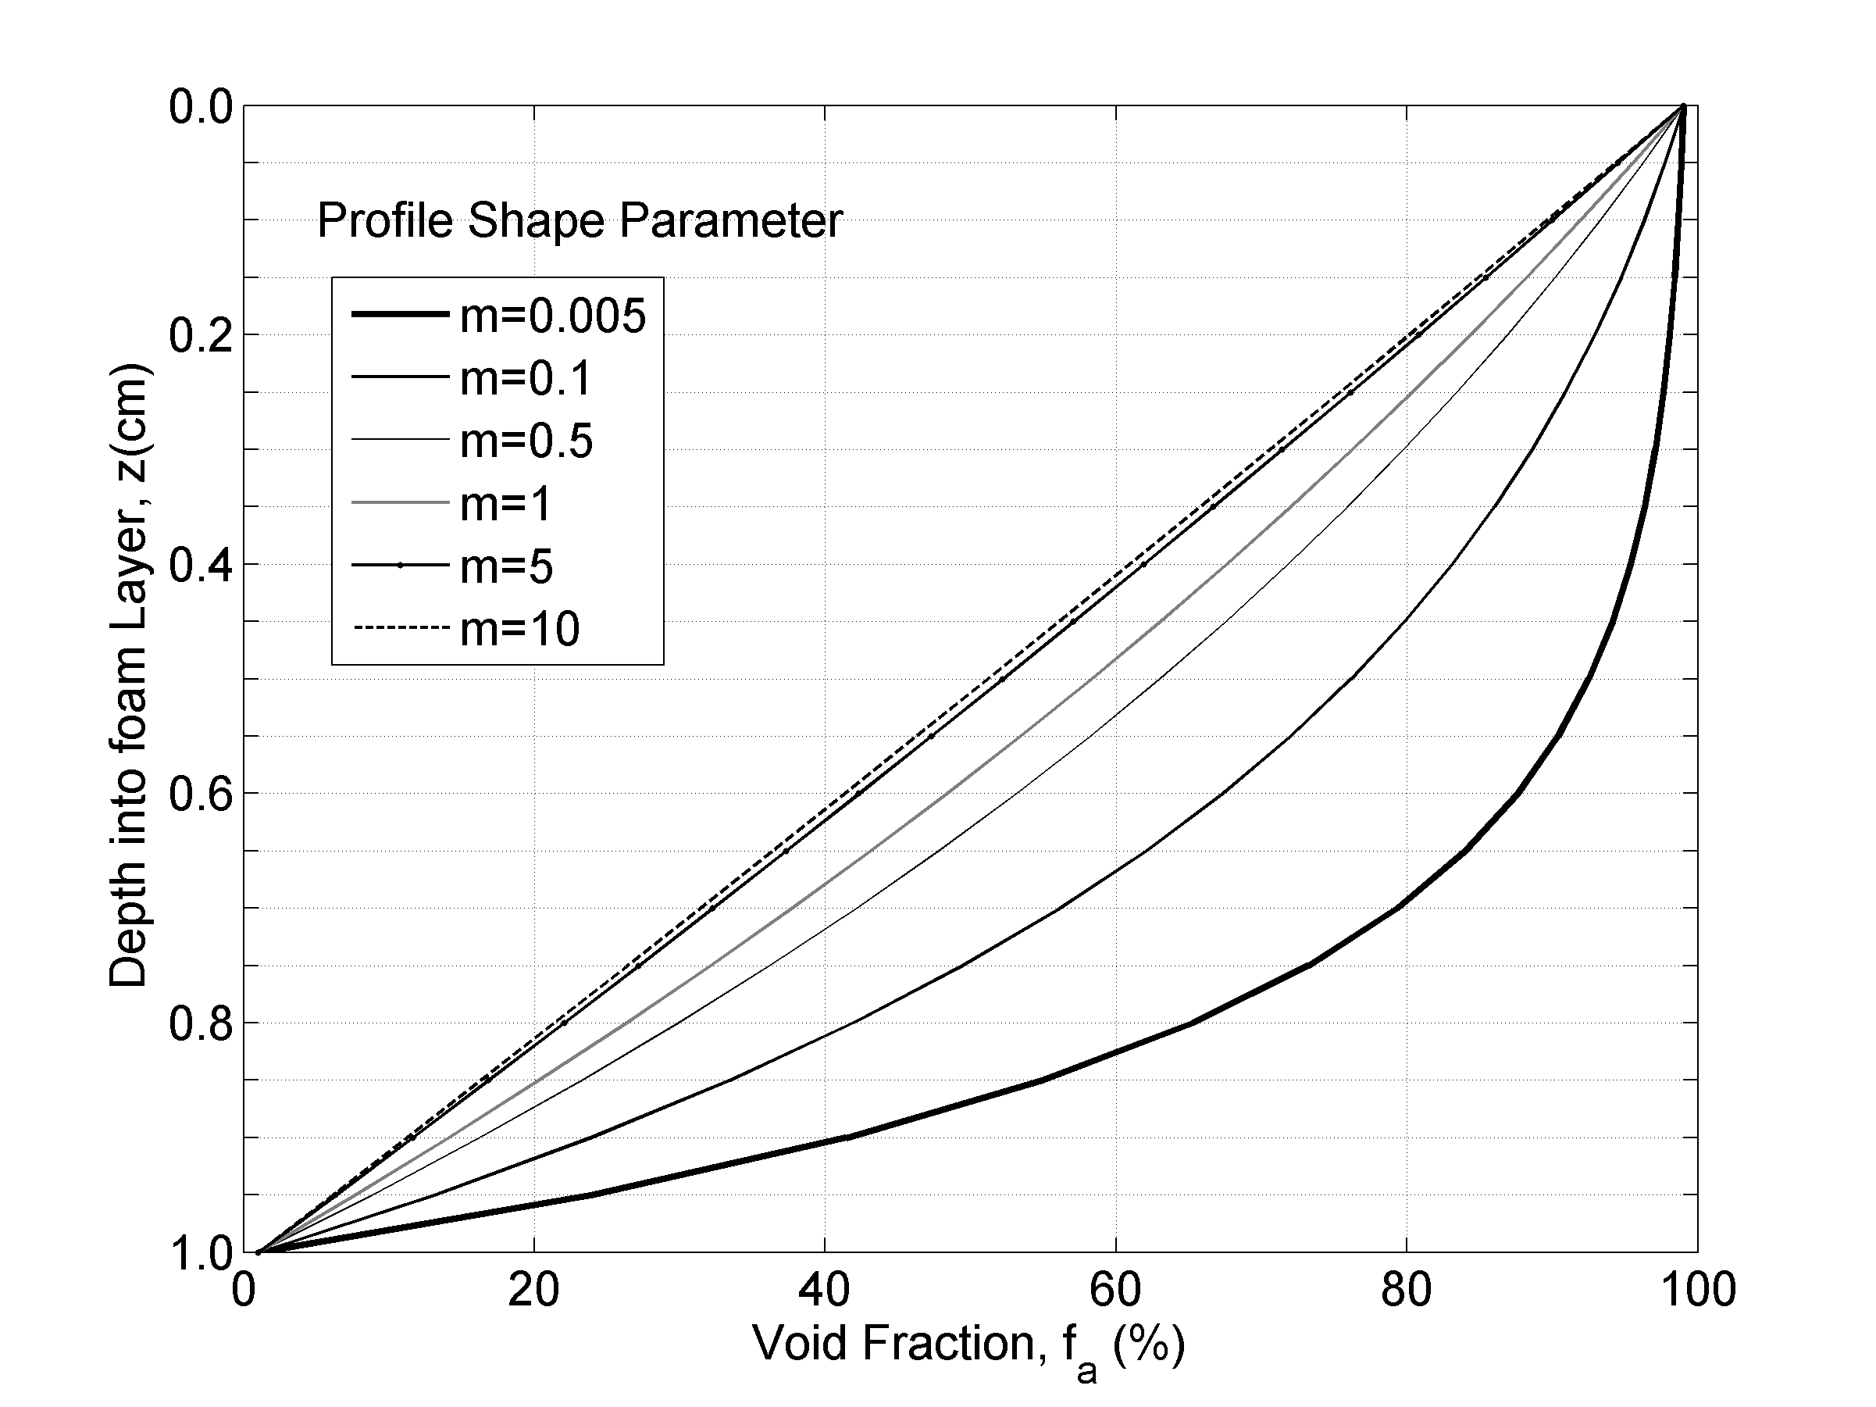

Figure(1) :Exponential void fraction profile fa(z) in foam layer with thickness FTL = 1 cm; z = 0 is the air–foam interface, z = 1 cm is the foam–water interface. If FLT changes, the shape of fa(z) is preserved. Parameter m changes the shape of fa(z).

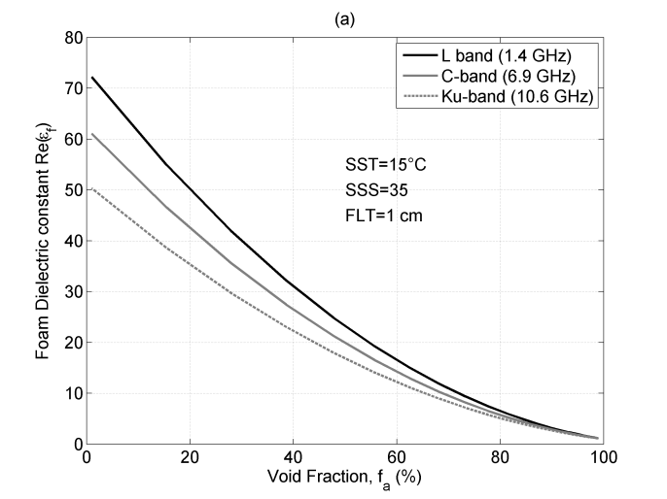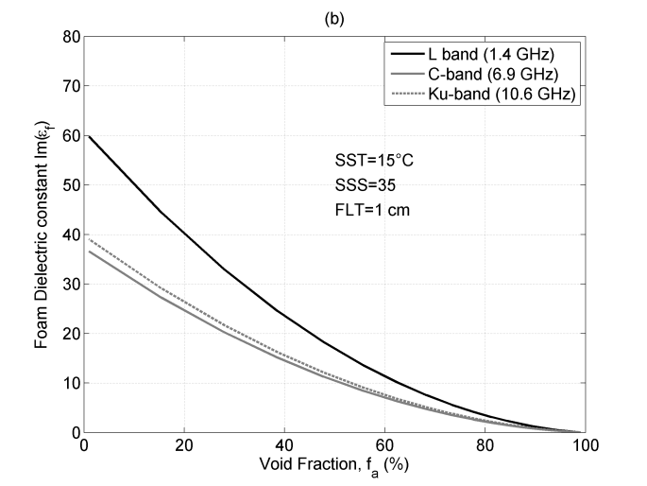

Complex dielectric constant of sea foam obtained with the refractive mixing rule as a function of foam void fraction εf (fa) for three frequencies at fixed seawater temperature

Ts = 15 °C and salinity S = 35 psu for a Foam Layer Thickness (FLT) of 1 cm and at frequency of 1.4 GHz; 6.9.7 GHz and 10.6 GHz. (a) shows the real part of εf; (b) shows imaginary εf.

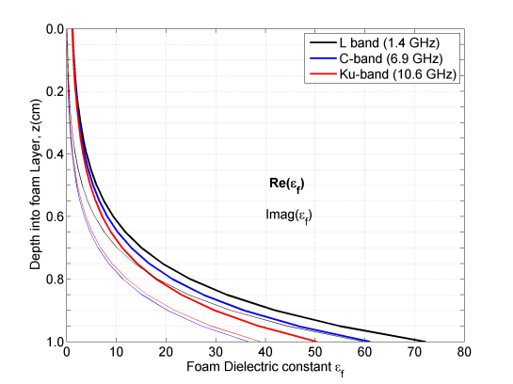

Vertical profile of the foam dielectric constant with depth in the foam εf (z) obtained with an exponential void fraction profile fa(z) (see Section 3.2.1) and refractive mixing

rule (see Section 3.2.2) for a layer with thickness t = 2 cm at three frequencies: 6.8 GHz (dash-dotted curves), 18.7 GHz (solid curves), and 37 GHz (dashed curves). Black and gray curves represent the real ε′f = Re{εf(z)} and imaginary ε″f = −Im{εf(z)} parts.

